Former Quiz Problem, given in an election year.

MBTA busses from Boston, going towards Harvard Square, arrive at 77 Massachusetts Avenue according to a homogeneous Poisson Process at rate 6/hour. This being election season, two political parties have purchased the rights to paint the busses on the outside. Half the busses are totally and 100% blue, the other half are totally and 100% red. The dispatching of busses from the terminal in Boston arranges them so that the colors alternate, one red, one blue, one red, another blue, etc. So, if there were an observer watching the Poisson arrival of busses from Boston at 77 Massachusetts Avenue, she would see a sequence of alternating red and blue busses. Busses do not pass each other.

Part A: (5 Points)
You arrive at 77 Massachusetts Avenue at a random time, wanting to go to Harvard Square. What is your average curbside waiting time until the next bus arrives? If you get on the next bus that arrives, what is the likelihood that you will board a red bus?

Part B: (5 Points)
Your friend is a Democrat and will only board a blue bus. He arrives at 77 Massachusetts Avenue at a random time. What is his average curbside waiting time until the next blue bus arrives from Boston?

Part C: (5 Points)
In a random hour of operation, determine the probability mass function for the number of red busses that arrive from Boston at 77 Massachusetts Avenue. [Hint: Think of how the number of red busses can take on any particular non-negative integer value.]

Part D: (10 Points)
Once the busses arrive at Harvard Square and the bus drivers take a rest break, the bus dispatchers there are not concerned about creating an alternating sequence of busses -- red, blue, red, blue, etc. In fact, the color of any bus leaving Harvard Square towards MIT and Boston is equally likely to be red or blue. The departure process at Harvard Square is still a homogenous Poisson process at rate 6/hour, as is the arrival process at 77 Massachusetts Avenue, going towards Boston. Colors of successive busses are mutually independent. For a person leaving 77 Massachusetts Avenue towards Boston (not Harvard Square), repeat parts (b) and (c).

Part E: (10 Points)
Reconsider your friend the Democrat of Part (b), arriving at 77 Massachusetts Avenue at a random time and waiting for a bus to Harvard Square. Again, he will only board a blue bus to Harvard Square. But every red bus he sees while waiting increases his stress level S by a factor f, where 1 < f < . His initial stress level S₀ = 2.0. It does not matter to him whether the red bus he sees is heading towards Harvard Square or Boston. For example, it is possible for him to see one red bus going towards Harvard Square and 3 red busses towards Boston while he is waiting for a blue bus to Harvard Square; in this case, his stress level S becomes 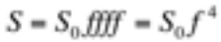. Find the probability mass function of his stress level S once he finally boards a blue bus going towards Harvard Square.
Solutions for Former Election-Year Quiz Problem

A. When you arrive at the bus stop, by the memoryless property of the Poisson process the pdf for the time until the next bus arrival is an exponential with rate lamda. Hence the expected time is 1/lamda. This amounts to 1/(6/60)= 10 min.

The probability you board a red bus is the fraction of busses that are red. In this case it would be 1/2.

B. The probability the next bus will be a blue bus is 1/2. If this is the case the conditional expected waiting time is the same as the result in part A (10 min). If the next bus is a red bus we know the bus that follows will be a blue bus. In the case we have to wait for the second arrival, and the total waiting time is the sum of two iid (independent identically distributed) exponential random variables. The total conditional expected waiting time in this case is 10min+10min or 20 min.

E[waiting time for the next blue bus]=P(next bus is blue)*E[waiting time|next bus is blue]+ P(next bus is red)*E[waiting time|next bus is red)= .5*10+.5*20=15min

C. We need to consider two equally likely cases, plus a third case. The first case is that the first bus that arrives is red, the second case is that a blue bus is the first to arrive. The third case is that no bus arrives.

Let x be the number of red busses arriving within an hour. For the first case we have two possibilities: The first is that the last bus to arrive is also a red, hence we have 2x-1 total arrivals. The second is the last bus to arrive is a blue and we have an equal number of each color or 2x total. We need to sum these two cases.

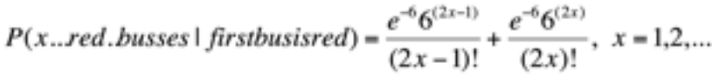

In the second case we also have two possible cases, but here if we want x red busses we need either 2x or 2x+1 total busses, where we assume x > 0,

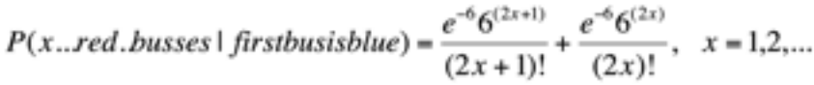

Each case is equally likely giving us for x > 0,

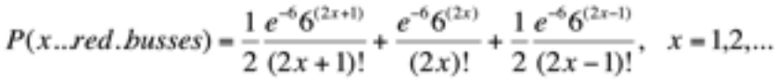

But we are not yet finished! We need to consider the probability of having zero red busses. This occurs if zero busses of any color appear in an hour or if only one appears and it is blue.
.

D. The arrival process for blue busses in this case is now a Poisson process with rate 3, since half of the busses are blue. This comes from the concepts of splitting the Poisson process. Thus using the logic of part A is expected waiting time for a blue bus is 60/3= 20 min.

The probability that a bus is blue is 1/2, so each bus that arrives independently has a probability of being blue equal to 1/2. Thus the number of blue busses in an hour has a Poisson distribution with parameter 3 or,

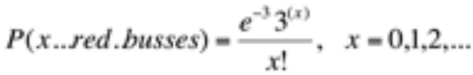

E. We again have two disjoint cases to consider. The first is that the next bus going to Harvard Square is a blue bus. The probability of this event is 1/2. The Poisson arrival rate is 6/hr. The Poisson arrival rate for red busses going in the opposite direction is 3/hr. The 2 processes operate independently. So, we have two ‘competing”’ Poisson processes here, and the chance that the next event will be from the first process is 6/(6 + 3) = 2/3. The chance that the next bus will be a red one (from Harvard Square) is 3/(6 + 3) = 1/3. Since events in non-overlapping time intervals are independent, we see that the identity of each successive bus is essentially an independent Bernoulli coin flip with probability 1/3 red and 2/3 blue. The process terminates with the arrival of the first blue bus. Thus the conditional pmf for N, the number of red busses observed before the first blue bus from Boston towards Harvard Square, is geometric:

Now consider Case 2, in which the next bus from Boston to Harvard Square is red. We know that stress level will rise, because our passenger will see at least one red bus. Suppose we consider two random variable, N and M, where

N = number of red busses seen coming from Harvard Square before the first bus (which is red) coming from Boston,

and

M = number of red busses seen coming from Harvard Square after the first bus (which is red) coming from Boston but before the 2nd bus (which is blue).

By reasoning similar to that above, we can write,

But we are interested in the total number of red busses seen, given that the next bus to Harvard Square is red. Clearly the minimum number is 1, and that occurs only if N and M take on identical experimental values, N = M = 0. To obtain the pmf of the total number of red busses seen, we must add the one from Boston (with certainty) to the others from Harvard Square, with uncertainty. Suppose a total of 3 busses come from Harvard Square. This could occur in four ways: (N = 4, M = 0); (N = 3, M = 1); (N = 2, M = 2); (N = 1, M = 3); (N = 0, M = 4). In general, if k busses come from Harvard Square, this can occur in k + 1 equally likely ways, as shown by the formula above.

Let N be our unconditional r.v., representing the total number of red busses that our waiting Democrat sees (in either direction). Putting all of this together and recalling that each of the 2 situations above has a (1/2) probability of occurrence, we can write,

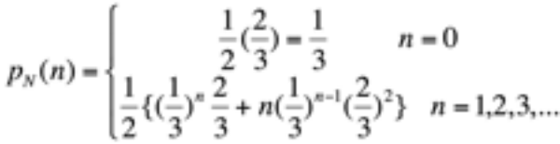

So, our friend’s stress level varies probabilistically according to the pmf above, where the functional form is that given in the problem statement.

If we simplify the above expression, we see that the 2nd term can be expressed as

Thus, a compact form of the answer is given,



